Concept:

The LangChain Expression Language (LCEL) takes a declarative approach to building new Runnables from existing Runnables.

This means that you describe what should happen, rather than how it should happen, allowing LangChain to optimize the run-time execution of the chains.

We often refer to a Runnable created using LCEL as a "chain". It's important to remember that a "chain" is Runnable and it implements the full Runnable Interface.

Benefits of LCEL

LangChain optimizes the run-time execution of chains built with LCEL in a number of ways:
- Optimized parallel execution: Run Runnables in parallel using RunnableParallel or run multiple inputs through a given chain in parallel using the Runnable Batch API. Parallel execution can significantly reduce the latency as processing can be done in parallel instead of sequentially.
- Guaranteed Async support: Any chain built with LCEL can be run asynchronously using the Runnable Async API. This can be useful when running chains in a server environment where you want to handle large number of requests concurrently.
- Simplify streaming: LCEL chains can be streamed, allowing for incremental output as the chain is executed. LangChain can optimize the streaming of the output to minimize the time-to-first-token(time elapsed until the first chunk of output from a chat model or llm comes out).
- Other benefits include:
- Seamless LangSmith tracing As your chains get more and more complex, it becomes increasingly important to understand what exactly is happening at every step. With LCEL, all steps are automatically logged to LangSmith for maximum observability and debuggability.
- Standard API: Because all chains are built using the Runnable interface, they can be used in the same way as any other Runnable.
- Deployable with LangServe: Chains built with LCEL can be deployed using for production use.

Should I use LCEL?

LCEL is an orchestration solution -- it allows LangChain to handle run-time execution of chains in an optimized way.
While we have seen users run chains with hundreds of steps in production, we generally recommend using LCEL for simpler orchestration tasks. When the application requires complex state management, branching, cycles or multiple agents, we recommend that users take advantage of LangGraph.
In LangGraph, users define graphs that specify the application's flow. This allows users to keep using LCEL within individual nodes when LCEL is needed, while making it easy to define complex orchestration logic that is more readable and maintainable.
- guidelines:
- If you are making a single LLM call, you don't need LCEL; instead call the underlying chat model directly.
- If you have a simple chain (e.g., prompt + llm + parser, simple retrieval set up etc.), LCEL is a reasonable fit, if you're taking advantage of the LCEL benefits.
- If you're building a complex chain (e.g., with branching, cycles, multiple agents, etc.) use LangGraph instead. Remember that you can always use LCEL within individual nodes in LangGraph.

Composition Primitives

LCEL chains are built by composing existing Runnables together. The two main composition primitives are RunnableSequence and RunnableParallel.
Many other composition primitives (e.g., RunnableAssign) can be thought of as variations of these two primitives.
Code Explanation
• Simple Chain: Combines prompt, model, and parser:
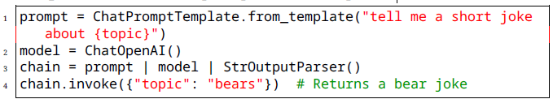
• Complex Chain with Retrieval: Uses RunnableMap for dynamic inputs:
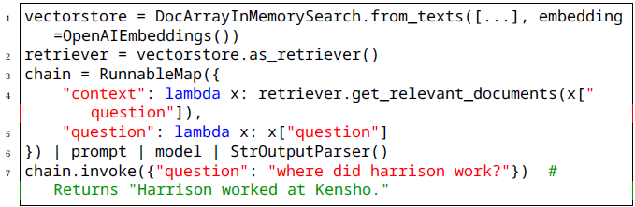
• Fallbacks: Handles errors with alternative chains:
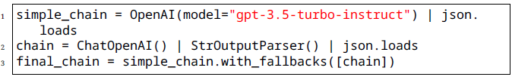

Chains: Building Linear and Parallel Logic
In modern LLM applications, Chains are essential for building structured workflows where multiple components — like prompts, models, retrievers, or tools — are connected together.

Definition: Chain

A Chain is a sequence of steps that process data from an initial input to a final output. Each step can be a language model, a prompt, a retriever, a function, or a custom logic block.
There are two main types of logic you can build with Chains:

Basics of Chains

A Chain in LangChain is like a ready-made workflow that connects different parts of our AI system in a specific order to complete a task.
Whether it’s a prompt, a language model, a retriever, or even another chain — if it’s part of a chain, it can pass information smoothly to the next step.
This setup is helpful because it saves time and effort.
Instead of writing code from scratch to pass data between components, you can simply link them together like steps in an assembly line.
The main idea is to make it easier for developers to design, execute, and manage AI workflows without worrying about how each part runs internally.
So, in conclusion, we can say that Chains make it simple to connect and control multiple LangChain components in a logical order.
But wait — you might ask: If Runnables can already connect components, why do we need Chains?

Need for Chains

- High-Level Workflow Design: While Runnables provide a low-level, flexible interface, Chains give you a higher-level structure to organize multiple steps into a single, reusable task.
- Task-Oriented: A Chain is often built with a specific goal in mind — e.g., generating a summary, doing multi-step reasoning, or extracting data.
- Ease of Use: Chains often come with prebuilt logic for common patterns, so you can start quickly without building everything manually from primitives.
- Multiple Flow Types: Chains can be sequential, parallel, or even conditional, supporting various application needs without extra wiring.

Types of Chains

Chains can be broadly classified into two categories: Task-Specific Chains and Generic Chain Patterns.

a . Task-Specific Chains
These are pre-designed chains created for a particular job. They were originally separate utilities, but LangChain has made them part of the chain ecosystem so they all follow the same rules and can connect easily.
Examples:
- LLMChain: A chain that formats user input into a prompt and sends it to an LLM.
- RetrievalQA Chain: Combines a retriever with an LLM to answer questions from a document store.
- Summarization Chain: Takes text and outputs a summary in one or more steps.

b . Generic Chain Patterns
These are structural templates that control how multiple components run together. They don’t do AI tasks by themselves, but they define execution logic.

SequentialChain (Linear Logic)

- Runs steps one after another.
- The output of each step becomes the input to the next.
- Useful for multi-step reasoning or data transformations.
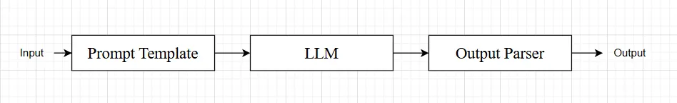

Example: SequentialChain Use Case
- User enters a sentence
- Classify the sentiment (positive or negative)
- Generate a short advice based on the sentiment
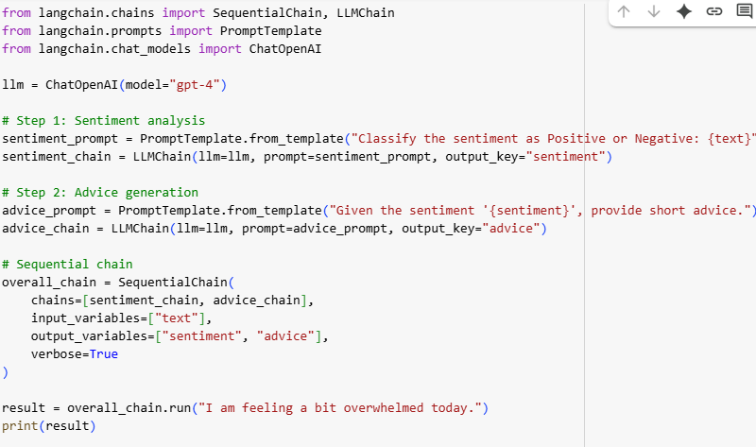

6. ParallelChain (Parallel Logic)
ParallelChain in LangChain allows us to run several chains at the same time, using the same input, and then gather all their outputs into a single dictionary.
It is particularly useful when we need to process the same data in different ways simultaneously. Since the chains run in parallel, it can save time compared to running them one by one.
A ParallelChain is best suited for independent chains, where the output of one chain does not depend on another. Each branch of the parallel structure is its own chain (for example, one chain could analyze sentiment while another extracts keywords), and all results are returned together.
Goal:
- User enters a sentence
- Run two different analyses at the same time:
  - Classify the sentiment (positive/negative)
  - Detect the main topic of the sentence
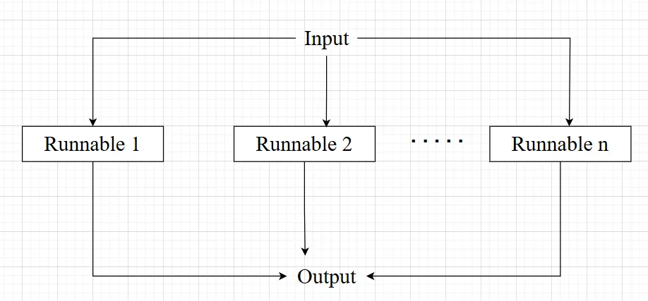
from langchain_google_genai import GoogleGenerativeAI
from langchain_core.prompts import PromptTemplate
from langchain_core.output_parsers import StrOutputParser
from langchain_core.runnables import RunnableSequence, RunnableParallel

from dotenv import load_dotenv
load_dotenv()

llm = GoogleGenerativeAI(model="gemini-1.5-flash")
parser = StrOutputParser()

sentiment_prompt = PromptTemplate(
template="Classify the sentiment of this sentence as Positive of Negative: {sentence}",
input_variables=["sentence"]
)

keywords_prompt = PromptTemplate(
template="Give me keywords in the sentence: {sentence}",
input_variables=["sentence"]
)

feedback_prompt = PromptTemplate(
template="Write an appropriate feedback in one sentence to the sentence: {sentence}",
input_variables=["sentence"]
)

parallel_runnable = RunnableParallel(
{
"sentiment": RunnableSequence(sentiment_prompt, llm, parser),
"keywords": RunnableSequence(keywords_prompt, llm, parser),
"feedback": RunnableSequence(feedback_prompt, llm, parser)
}
)

response = parallel_runnable.invoke({"sentence": "I am not feeling well today."})
print(type(response))
print(response)

print(f"""\n\nSentiment: {response["sentiment"]}\nKeywords: {response["keywords"]}\nFeedback: {response["feedback"]}\n\n
""")

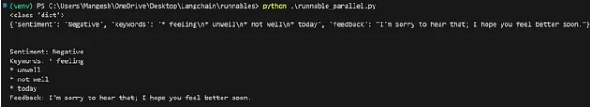

ConditionalChain
- Runs different steps depending on certain conditions in the input or intermediate results.
- Useful for decision-based workflows.

What You're Aiming For
- What LCEL gives us
LCEL (LangChain Expression Language) is a declarative way to compose LangChain components (called Runnables) into chains. Use the pipe operator | (or .pipe) to make sequences, and RunnableParallel / batch for parallelism.
Prompt templates and chat models are themselves Runnables, so you can PromptTemplate | ChatModel and that becomes a single runnable you can pipe into the next step.

LCEL composition by building a pipeline that (1) decomposes a question into up to 3 numbered sub-questions, (2) answers each sub-question (returning plain text with a short reasoning list), and (3) synthesizes a final short answer
2. Learning objectives
- Use LCEL pipes (|) to compose prompts and models.
- Run sub-questions in parallel or batch (efficiency).
- Parse plain-text model outputs (numbered lists, labeled lines)

Instructions
3. Practical example (Python, LangChain LCEL)

# lcel_no_json_example.py
from langchain_core.prompts import PromptTemplate
from langchain_core.runnables import RunnableLambda
from langchain_community.chat_models import ChatOpenAI
import re

# 1) Decomposer: ask LLM to return numbered sub-questions like:
# "1. ...\n2. ...\n3. ..."
decompose_prompt = PromptTemplate.from_template(
"Split the question into up to 3 concise sub-questions. "
"Return them as a numbered list (1., 2., 3.), nothing else.\n\nQuestion:\n{question}"
)
decomposer = decompose_prompt | ChatOpenAI(model="gpt-3.5-turbo", temperature=0.0)

def parse_numbered_subquestions(base_msg):
text = getattr(base_msg, "content", str(base_msg)).strip()
# find lines starting with "1." or "1)"
lines = re.split(r"\r?\n", text)
subqs = []
for line in lines:
m = re.match(r"\s*\d+\s*[.)]\s*(.*\S.*)$", line)
if m:
subqs.append(m.group(1).strip())
# fallback: if nothing matched, treat whole text as one subquestion
if not subqs and text:
subqs = [text]
return subqs

parse_subq_runnable = RunnableLambda(parse_numbered_subquestions)

# 2) Answer each sub-question returning plain text with label lines:
# "Answer: <one-line answer>\nSteps:\n- step1\n- step2"
answer_prompt = PromptTemplate.from_template(
"You are a concise assistant. For the sub-question below, produce:\n"
"Answer: <one-line answer>\nSteps:\n- <step1>\n- <step2>\nKeep it short.\n\nSub-question: {subq}"
)
answer_chain = answer_prompt | ChatOpenAI(model="gpt-3.5-turbo", temperature=0.2)

def run_answers(subquestions):
# call in batch: prepare inputs
inputs = [{"subq": q} for q in subquestions]
outputs = answer_chain.batch(inputs) # returns list of BaseMessage-like
parsed = []
for out in outputs:
text = getattr(out, "content", str(out)).strip()
# extract Answer line and Steps bullet lines
answer_line = None
steps = []
for line in text.splitlines():
if line.lower().startswith("answer:"):
answer_line = line.split(":", 1)[1].strip()
elif re.match(r"\s*[-•]\s+", line):
steps.append(re.sub(r"^\s*[-•]\s+", "", line).strip())
# fallback: if nothing parsed, keep raw text
parsed.append({"answer": answer_line or text, "steps": steps or ["(no steps parsed)"], "raw": text})
return parsed

run_answers_runnable = RunnableLambda(run_answers)

# 3) Combiner: synthesize final short answer from the list of plain sub-answers
combine_prompt = PromptTemplate.from_template(
"Synthesize a single concise final answer from these numbered sub-answer blocks.\n\n"
"Input (each item is like 'Answer: ...' and 'Steps: - ...'):\n{subanswers_text}\n\n"
"Return exactly three lines:\n1) Final Answer: <one line>\n2) Key points: - <p1>; - <p2>\n3) Confidence: <low/medium/high>"
)
# helper to format subanswers into a plaintext block
def format_subanswers_block(ans_list):
blocks = []
for i, a in enumerate(ans_list, start=1):
blocks.append(f"{i}. Answer: {a['answer']}")
blocks.append(" Steps:")
for s in a["steps"]:
blocks.append(f" - {s}")
return "\n".join(blocks)

format_runnable = RunnableLambda(lambda answers: {"subanswers_text": format_subanswers_block(answers)})
combiner = format_runnable | combine_prompt | ChatOpenAI(model="gpt-3.5-turbo", temperature=0.0)

# Pipeline composition
pipeline = decomposer | parse_subq_runnable | run_answers_runnable | combiner

if __name__ == "__main__":
q = "How can I reduce latency in a web app that serves ML predictions?"
final = pipeline.invoke({"question": q})
print(getattr(final, "content", str(final)))

4. Notes for instructors
- Parsing uses simple regex and line-splitting — easy for students to reason about and implement.
- Emphasize why batch() / parallel runs matter (faster when answering many subparts).
- If a model output is messy, show students simple fallback patterns (treat entire text as single item).
- Later you can introduce JSON when they're comfortable with structured thinking.
5. Checkpoint / assignment
- Run the script on two different questions. Submit:
  - The decomposed sub-questions (as a copied numbered list).
  - The sub-answers (plain text blocks showing Answer + Steps).
  - The final 3-line synthesis from the combiner.
- Short README (≤150 words) explaining where LCEL pipes were used and why batch helps.
- Optional: Add a unit test that asserts the decomposer returns at most 3 sub-questions.

